
Application Form for Allotment of Accommodation
at International Guest House
National Agriculture Science Complex
Dev Prakash Shastri Marg, Opposite Dusghara Village, New Delhi-12

Name | Dr. Mahak Singh
Designation | Scientist
Full Official(if  employed) or Full Residentional  Address | ICAR RC for NEH Region, Nagand Centre, Medziphema, Nagaland-797106
Telephone No. | Mobile.09474939889 Office ......................... Res ........................
Purpose of Visit | Official |  |  |  | Private√  My treatment at Medanta Hospital, Gurgaon
Category (Pls. mark) | ICAR/SA√U | Retired ICAR/SAU | Central/State  Government |  | Retired  Central/State  Government |  |  | Foreigner | PSU/Others
Duration of stay | From 11/02/2018 |  |  |  |  | To 18/02/2018
Accommodation requested | Single room |  |  | Double Bed room√ |  |  | VIP suite
Total No.  Of Persons | 2
Signature with Date | 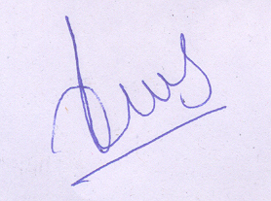10/01/2018
To
Under Secretary (E&M)
Estate & Maintenance Section
NASC Complex, New Delhi-110 012
Tel/Fax No. 011-25848029
Email-usem@icar.org.in
